Ideation Phase
Brainstorm & Idea Prioritization
Template
Date | 27 JUNE 2025
Team ID | NM2025TMID00377
Project Name | Calculating Family Expenses using Service Now
Maximum Marks | 4 Marks

Brainstorm & Idea Prioritization
The brainstorming phase encouraged open collaboration among team members to generate a wide range of ideas for automating and improving the Family Expense Calculation System in ServiceNow. The focus was on identifying innovative solutions that simplify expense tracking, enhance usability, and ensure accurate financial insights.
Ideas were collected through team discussions, whiteboard sessions, and ServiceNow workflow simulations. After evaluating each idea based on feasibility, impact, and implementation time, the top priorities included:
- Automated Expense Calculation: Automatically sum daily expenses and categorize spending.
- Budget Alert System: Notify users when monthly expenses exceed preset limits.
- Dynamic Dashboard: Display real-time expense analytics and category-wise summaries.
- Data Export Feature: Allow users to download reports in Excel or PDF formats.
- User-Friendly Interface: Simplify form layouts for quick and error-free data entry.

Step-1: Team Gathering, Collaboration and Select the Problem Statement
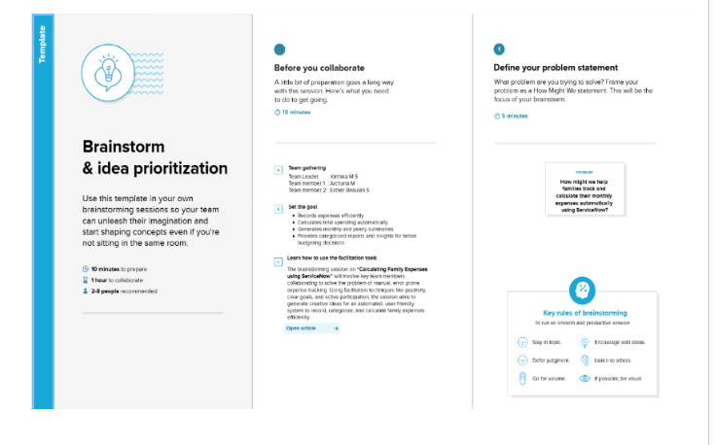
Step-2: Brainstorm, Idea Listing and Grouping
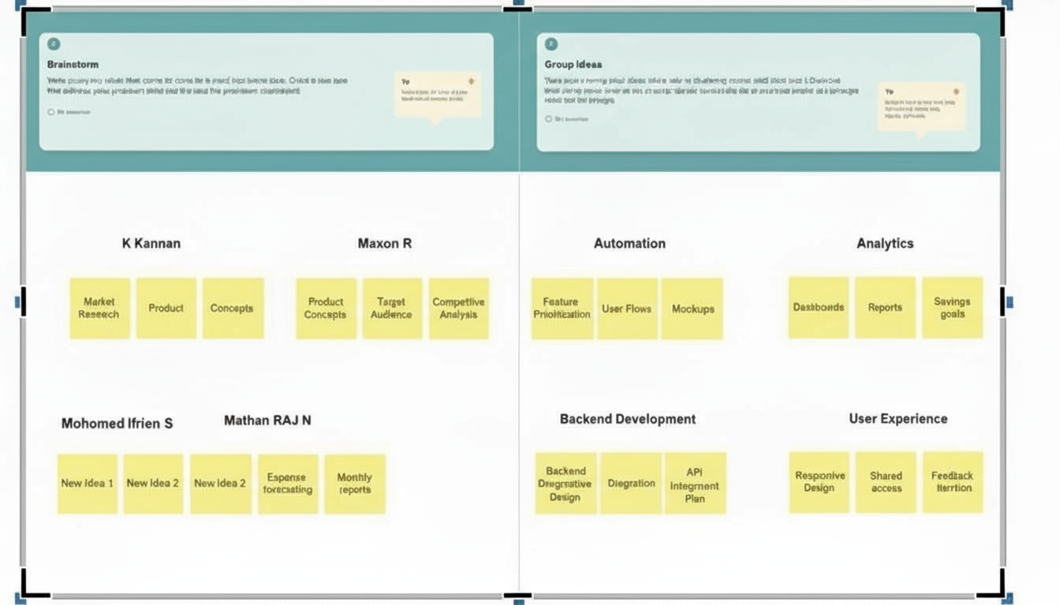

Step-3: Idea Prioritization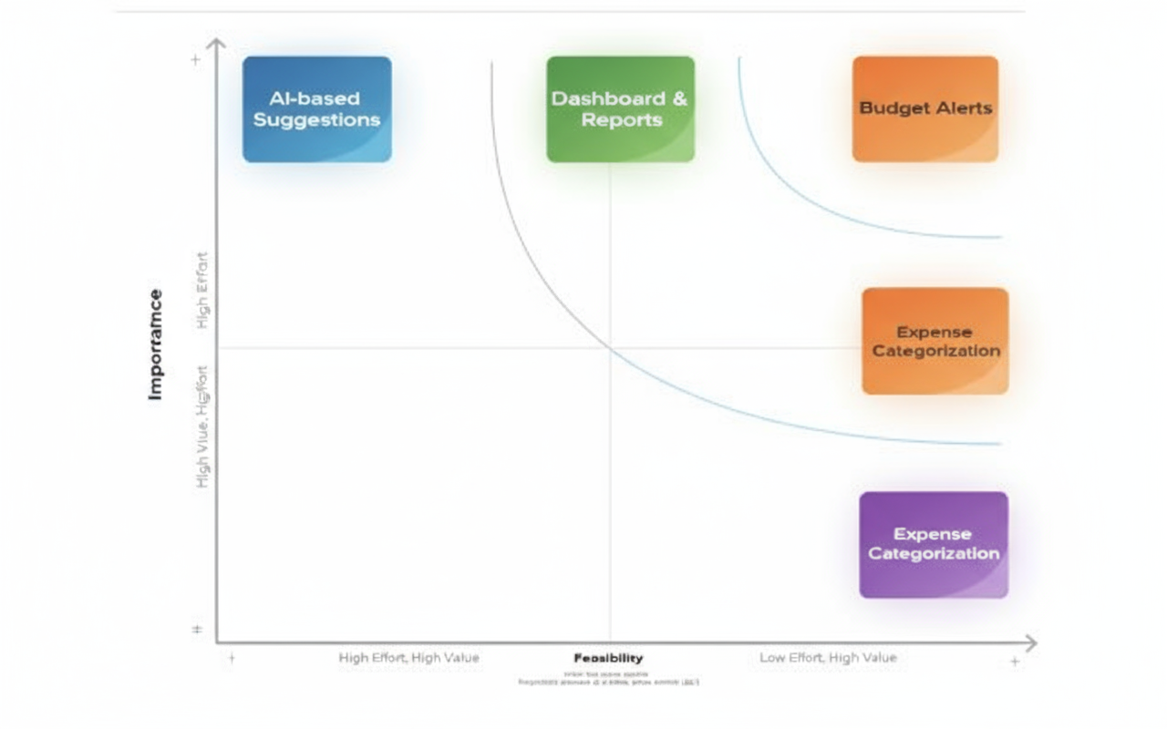

Conclusion
This ServiceNow-based family expense tracking system provides a comprehensive solution for managing household finances. By centralizing expense data, automating calculations, and providing insightful reports, families can gain better control over their spending and work toward their financial goals. The system's flexibility allows for customization to meet specific family needs, and its scalability ensures it can grow with changing requirements

